**SOLUTIONSMultiple Choice Answer Sheet**

1. A B C D 16. A B C D

2. A B C D 17. A B C D

3. A B C D 18. A B C D

4. A B C D 19. A B C D

5. A B C D 20. A B C D

6. A B C D 21. A B C D

7. A B C D 22. A B C D

8. A B C D

9. A B C D

10. A B C D

11. A B C D

12. A B C D

13. A B C D

14. A B C D

15. A B C D

**Short Answer**

**1** Classify the following as situations in which forces are balanced or unbalanced: 4

a A motorbike is accelerating away from traffic lights. Unbalanced

b A car is travelling at 100 km/h straight down a freeway. Balanced

c A surfer falls off their surfboard. Unbalanced

d A bird flies into a window and bounces off. Unbalanced

**2** Construct diagrams showing forces: 2

a in compression

Arrows pointing to each other

b in tension.

Arrows pointing away from each other

**3** Explain why a stretched cable is most likely to break at a scratch. You may use a diagram to help you. 2

Lines of stress are closer together at that point

More force in a smaller area

**4** Describe a simple way of determining whether part of a structure is in compression or tension. 1

Imagine that the part of the structure has been replaced with a length of rope. If under tension, then the rope will be taut. If under compression, then the rope will collapse and form S bends.

Any reasonable answer

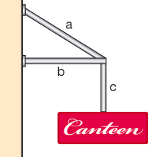**5**` Classify each of the components (labelled a, b and c) in the structure below as being in compression or tension. 3

**a** tension

**b** compression

**c** tension

**6** When a structure fails, it doesn’t always fall down. List two ways you can tell that some minor failure has occurred in a structure. 2

Any 2 reasonable answers

[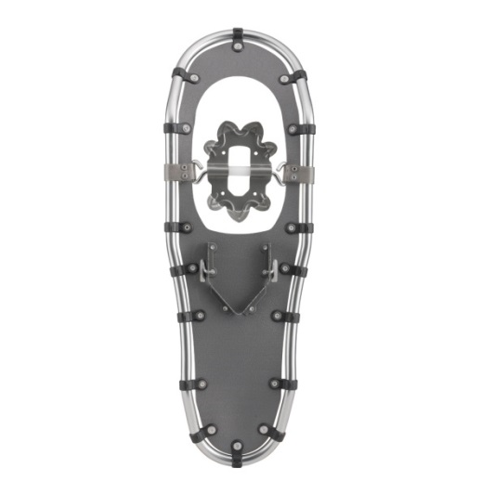](http://www.google.com.au/url?sa=i&rct=j&q=snow+shoes+pressure&source=images&cd=&cad=rja&docid=cm8BbMfRO8yOHM&tbnid=Ku39sujIMBYOgM:&ved=0CAUQjRw&url=http://www.louisgarneau.com/ca-en/product/0/1493980/_/BLIZZARD_930_SNOWSHOES&ei=fPM3UuywOofJkgXw44DIDg&psig=AFQjCNHkODeRA6Jg58j7gcAG6ZoSEgQXpA&ust=1379484887573019)**7** This is a picture of a snow shoe, which is a shoe designed to be strapped to your boots to help you walk in snow. Explain how the snow shoe makes it easier to walk in snow. 2

Larger area

Less force on each cm2

**8** Fill in the following table 3

|  |  |
| --- | --- |
|  | **Units** |
| Force | Newtons |
| Energy | Joules |
| Work | Joules |
| Speed | m/s |
| Acceleration | m/s2 |
| Kinetic Energy | Joules |